Visualization Python Cheat sheet

Table of Contents

Common Section 2

Matplotlib Library 2

1. Line Plot 2

2. Subplots 2

3. Learning and Validation Plots with Matplotlib and sklearn library 4

4. 3D Matplotlib 5

Seaborn Library 6

1. Heatmap 6

2. Scatter Plots 7

3. Swarm Plots 8

4. Box Plots 9

5. Pair Plot 10

# **Common Section**

dataset = pd.read_csv(‘Name_of_the_csv_file.csv’)

name_of_cols = list(dataset)[1:-1] #Name of Feature Columns

name_output_col = ‘class’

# **Matplotlib Library**

import matplotlib.pyplot as plt

%matplotlib inline

## **Line Plot**

plt.figure(figsize=(25, 5))

plt.plot(x_df, y_df, color='red', linestyle='dashed', marker='o', markerfacecolor='blue', markersize=10)

plt.title('Error Rate K Value')

plt.xlabel('K Value')

plt.ylabel('Test Error')

plt.gca().invert_xaxis() #This is to invert the X-Axis

plt.show()

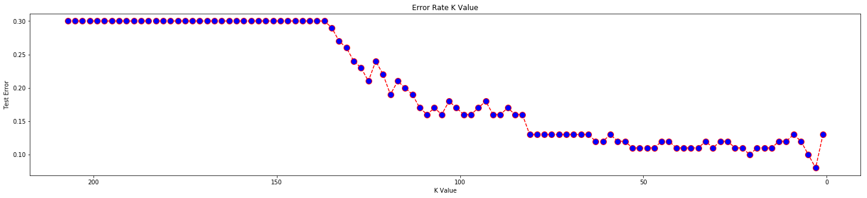

## **Subplots**

fig, axes = plt.subplots(2, 1, figsize=(25, 20), squeeze=False)

#Axes – 0 row 0 column

axes[0,0].plot(val, results['mean_train_AUC'], label='AUC ROC SCORE',color='g', marker='o', linestyle='dashed',linewidth=2, markersize=12)

axes[0,0].plot(val, results['mean_train_Accuracy'], label='ACCURACY SCORE',color='r', marker='+', linestyle='dashed',linewidth=2, markersize=12)

axes[0,0].plot(val, results['mean_train_Precision'], label='PRECISION SCORE',color='b', marker='s', linestyle='dashed', linewidth=2, markersize=12)

axes[0,0].plot(val, results['mean_train_Recall'], label='RECALL SCORE',color='k', marker='x', linestyle='dashed',linewidth=2, markersize=12)

axes[0,0].set_xlabel('K Parameter', fontsize=25)

axes[0,0].set_ylabel('Performance', fontsize=25)

axes[0,0].set_title('TRAIN SCORES', fontsize=30)

axes[0,0].legend(loc='lower right', prop={'size': 20})

#Axes – 1 Row 0 Column

axes[1,0].plot(val, results['mean_test_AUC'], label='AUC ROC SCORE',color='g', marker='o', linestyle='dashed', linewidth=2, markersize=12)

axes[1,0].plot(val, results['mean_test_Accuracy'], label='ACCURACY SCORE',color='r', marker='+', linestyle='dashed', linewidth=2, markersize=12)

axes[1,0].plot(val, results['mean_test_Precision'], label='PRECISION SCORE',color='b', marker='s', linestyle='dashed', linewidth=2, markersize=12)

axes[1,0].plot(val, results['mean_test_Recall'], label='RECALL SCORE',color='k', marker='x', linestyle='dashed', linewidth=2, markersize=12)

axes[1,0].set_xlabel('K Parameter', fontsize=25)

axes[1,0].set_ylabel('Performance', fontsize=25)

axes[1,0].set_title('TEST SCORES', fontsize=30)

axes[1,0].legend(loc='lower right', prop={'size': 20})

plt.gca().invert_xaxis()

fig.subplots_adjust(hspace=0.4)

plt.show()

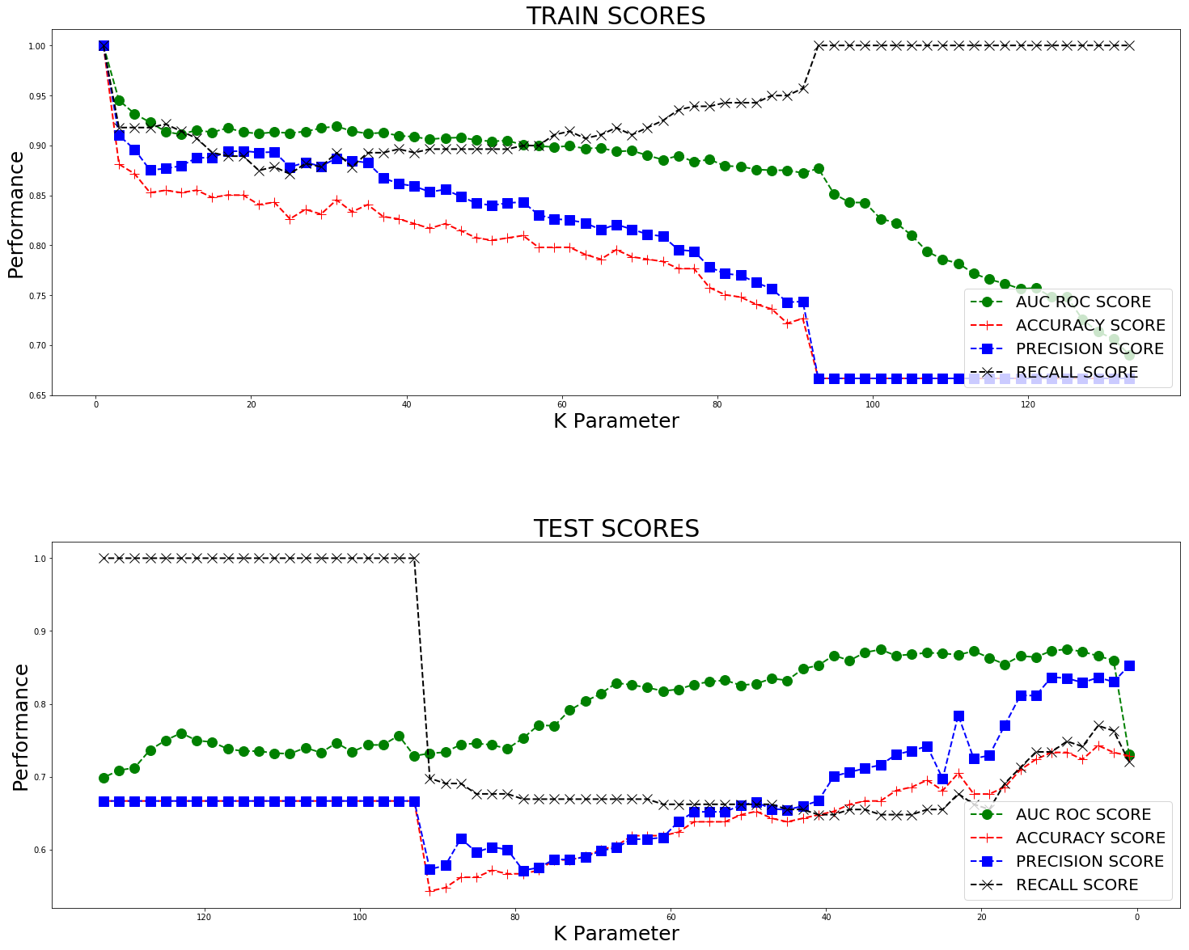

## **Learning and Validation Plots with Matplotlib and sklearn library**

#Making Learning Curve using Sklearn Library

from sklearn.model_selection import learning_curve

#Cross Validation

from sklearn.model_selection import validation_curve

paramr = list(range(2,210,10))

train_scores, test_scores = validation_curve(

KNeighborsClassifier(), dataset.iloc[:, 1:-1], dataset.iloc[:, -1], param_name="n_neighbors",

param_range=paramr, cv=10, scoring="accuracy", n_jobs=1)

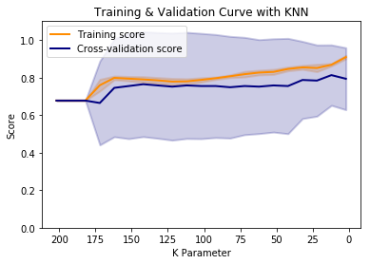train_scores_mean = np.mean(train_scores, axis=1)

train_scores_std = np.std(train_scores, axis=1)

test_scores_mean = np.mean(test_scores, axis=1)

test_scores_std = np.std(test_scores, axis=1)

plt.title("Training & Validation Curve with KNN")

plt.xlabel("K Parameter")

plt.ylabel("Score")

plt.ylim(0.0, 1.1)

lw = 2

plt.plot(paramr, train_scores_mean, label="Training score", color="darkorange", lw=lw)

plt.fill_between(paramr, train_scores_mean - train_scores_std, train_scores_mean + train_scores_std, alpha=0.2,

color="darkorange", lw=lw)

plt.plot(paramr, test_scores_mean, label="Cross-validation score", color="navy", lw=lw)

plt.fill_between(paramr, test_scores_mean - test_scores_std, test_scores_mean + test_scores_std, alpha=0.2,

color="navy", lw=lw)

plt.legend(loc="best")

plt.gca().invert_xaxis()

plt.show()

## **3D Matplotlib**

import matplotlib as mpl

from mpl_toolkits.mplot3d import Axes3D

mpl.rcParams['legend.fontsize'] = 10

#3D plot with all three parameters i.e. Training size N vs K Parameter vs Test Errors

fig = plt.figure(figsize=(10,7))

ax = fig.gca(projection='3d')

ax.plot(x, y, z, label='learning Curve',color='green', marker='o')

ax.legend(prop={'size':12})

ax.set_xlabel('Train Size', fontsize=12)

ax.set_ylabel('Optimal K Parameter', fontsize=12)

ax.set_zlabel('Best Test Errors', fontsize=12)

ax.set_title('Training size vs K Parameter vs Test Errors', fontsize=15)

plt.show()

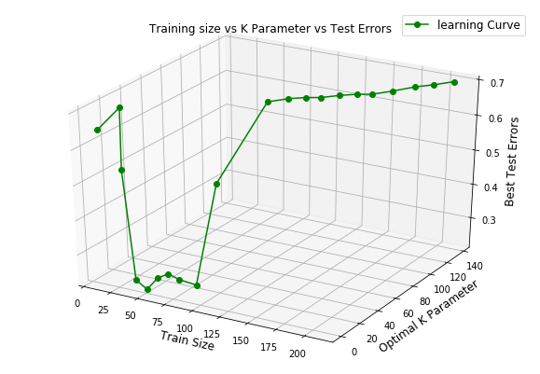

# **Seaborn Library**

Import seaborn as sns

## **Heatmap**

#Plotting a heatmap showing correlation between features

corr = dataset.iloc[:,1:-1].corr()

# Generate a mask for the upper triangle

mask = np.zeros_like(corr, dtype=np.bool)

mask[np.triu_indices_from(mask)] = True

# Set up the matplotlib figure

f, ax = plt.subplots(figsize=(11, 9))

# Generate a custom diverging colormap

cmap = sb.diverging_palette(220, 10, as_cmap=True)

# Draw the heatmap with the mask and correct aspect ratio

sb.heatmap(corr, mask=mask, cmap=cmap, vmax=.3, center=0, square=True, linewidths=.5, cbar_kws={"shrink": .5})

## 

## **Scatter Plots**

#Make scatterplots of the independent variables in the dataset. Use color to show Classes 0 and 1.

fig, axes = plt.subplots(2,3, figsize=(10,7))

ind = 0

#For Left Image – without much formatting

for i in range(2):

for j in range(3):

sb.scatterplot(x=name_output_col, y=name_of_cols[ind], data=dataset, hue='class', ax=axes[i,j])

ind = ind + 1

#style parameter: name of one column. It gives different markers to different features based on column passed.

#palette parameter: sb.color_palette("Set1", n_colors=’Number of Labels’) – General format to set palette

#For more palette option visit- #https://seaborn.pydata.org/generated/seaborn.color_palette.html#seaborn.color_palette

plt.setp(axes, yticks=[])

plt.tight_layout()

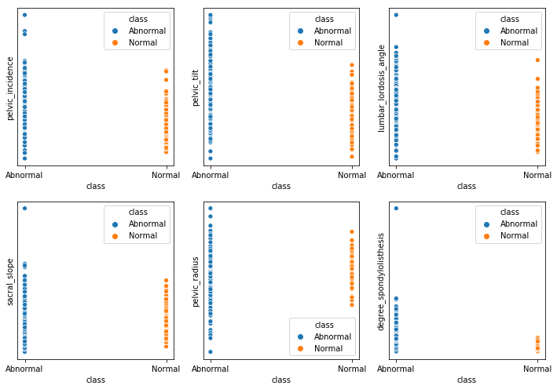

## **Swarm Plots**

#Make scatterplots of the independent variables in the dataset. Use color to show Classes 0 and 1.

fig, axes = plt.subplots(2,3, figsize=(10,7), sharey=True)

ind = 0

for i in range(2):

for j in range(3):

sb.swarmplot(x=name_of_cols[ind], y=name_output_col, data=dataset, hue='class',

palette=sb.color_palette("husl", n_colors=2),ax=axes[i,j])

ind = ind + 1

#Similar to Scatter plot, you can choose your own color palette

plt.setp(axes, yticks=[])

plt.tight_layout()

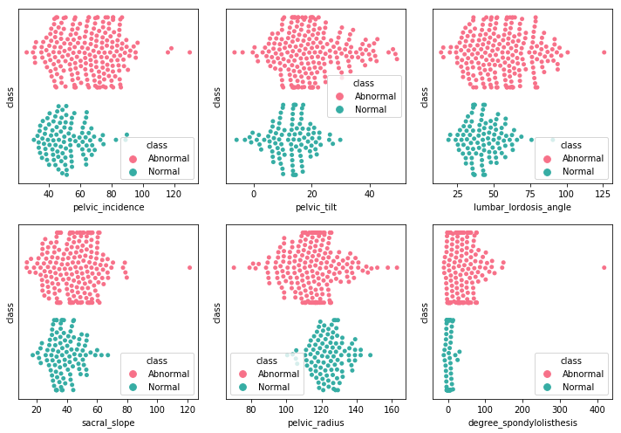

## **Box Plots**

#Make boxplots for each of the independent variables. Use color to show Classes 0 and 1

fig, axes = plt.subplots(2,3, figsize=(12,5), sharey=True)

ind = 0

for i in range(2):

for j in range(3):

sb.boxplot(x=name_of_cols[ind], y=name_output_col, data=dataset, hue='class', ax=axes[i,j])

ind = ind + 1

plt.setp(axes, yticks=[])

plt.tight_layout()

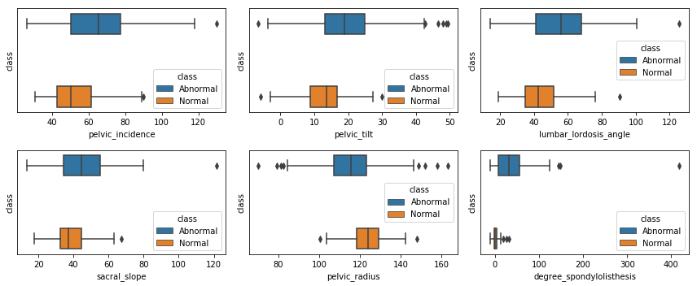

## **Pair Plot**

#The most AMAZING plot

sb.pairplot(dataset,hue='class',palette=sb.color_palette("muted", n_colors=2))

